**Lekha Sathvik Devabathini**

+ 91 8331981309 |  [github.com/dlsathvik04](mailto:github.com/dlsathvik04) |  [in/dlsathvik04](mailto:in/dlsathvik04)



 [dlsathvik04@gmail.com](mailto:dlsathvik04@gmail.com) |  [dlsathvik04.github.io](https://dlsathvik04.github.io/#/) |  [Ongole, Prakasam, Andhra Pradesh, India.](https://maps.app.goo.gl/3XbmFUyHHAYcbA2A8)

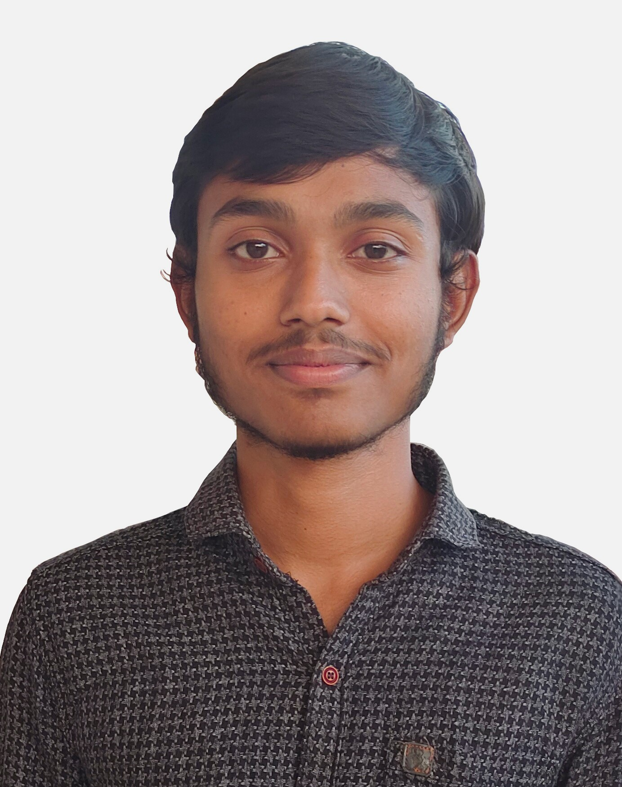

**Skills:**

Full-Stack Development, Mobile App Development, Machine Learning, Deep Learning, Research.

* **Programming Languages:**
  + Java
  + Python
  + JS/TS | HTML | CSS
  + Dart
* **Frameworks:**
  + Express.js
  + Flutter
  + Scikit-Learn
  + TensorFlow
  + Spring
  + Django
  + React
* **Tools:**
  + SQL
  + Git
  + Firebase
  + Bash
  + PowerShell
  + Linux
* **Soft skills:**
  + Project Organisation
  + Technical Writing
  + Presentation

**Courses:**

* freeCodeCamp - [Back End Development and APIs](https://www.freecodecamp.org/certification/dlsathvik04/back-end-development-and-apis) (300 h)
* freeCodeCamp - JavaScript Algorithms and Data Structures (300h)
* [Master Express Framework](https://www.udemy.com/certificate/UC-58bb2611-b0ce-492e-b7cc-eea7bd39ff3c/)
* Data Science with Python (UIITG-220309592)

**Achievements:**

* **Winners- Smart India Hackathon 2022** ([Certificate](https://raw.githubusercontent.com/dlsathvik04/dlsathvik04/main/certifications/SIH2022.jpeg))

Prototyped a machine learning based solution for detection of Dyslexia in children which uses various libraries cloud APIs.

**Profile:**

Undergraduate student hardened in software development and coding with rigorous exposure to various challenging projects in the areas of Development, AI & ML, and Data Analytics. Proven ability to trigger progress in stagnant projects with useful observations and creative insights with consistent work.

**Education:**

* **Amrita School of Computing: 2021 – Now (UG - 9.85/10 GPA till semester-5)**

Currently in semester-5 of B. Tech in Computer Science and Engineering, with specialization in Artificial Intelligence.

* **FIITJEE College, Vijayawada: 2019 – 2021 (11th and 12th – 95.6%)**
* **Jawahar Navodaya Vidyalaya: 2014 – 2019 (6th to 10th- 94%)**

**Internship:**

* **Intern at Amrita Centre for Wireless Networks and Applications (Oct 2022 – Present):**

Research on applications of Artificial Intelligence in Vehicular Networks. Full Stack development of Authentication module and Mathematical modelling of business logic for a finance application with scalability in mind.

Worked in the areas of: UI and UX design using flutter; API development using Express.js in Node.js; Database Management using MySQL, PostgreSQL and MongoDB; Machine Learning using Scikit-Learn; Deep Learning using TensorFlow.

* **Member at ACM-AI@Amrita (Apr 2022 – Feb 2023)**

Worked on Machine Learning, Deep Learning and Federated-Learning. Participated in various workshops and club activities.

**Projects:**

* [**Auth: Aug 2023** ](https://github.com/dlsathvik04/Auth)

Developed a client and server Full-Stack module built using Express and Flutter with login, registration and Forgot Password features which uses email for OTP As a part of software solution for women SHG’s which is to be scaled to lakhs of users.

**Tech Stack:** Node.js, Express.js, Flutter

* [**Device Control: Aug 2023** ](https://github.com/dlsathvik04/DeviceControl)

Developed an application for real-time control of devices. The application achieves near real-time control among multiple clients using Socket Programming.

**Tech Stack:** Java, Flutter, Dart, Sockets

* [**Portfolio: Apr 2023** ](https://github.com/dlsathvik04/Portfolio)

Created a website for developing my online presence built using Flutter.

**Tech Stack:** Flutter

**Website**:  [dlsathvik04.github.io](https://dlsathvik04.github.io/#/) 

* [**Dyslexia Detection using Machine Learning: Aug 2022** ](https://github.com/dlsathvik04/Dyslexia_Detection)

Developed a web application based on Machine Learning which uses handwriting samples of children to predict presence of dyslexia with 95% accuracy.

**Tech Stack:** Python, Scikit-Learn, Streamlit